SCM 518 - Final Course Project

Horizon Wealth Partners ETF Portfolio Optimization

Yimin Wan

December 12, 2025

Group Members:
Madison Jimenez
Tommy Koreen
Balraj Kooner
Gayatri Chavda

Executive Summary
Horizon Wealth Partners (HWP) is a financial advisory firm based in Lexington, MA, that manages more than 800 ETF portfolios. The firm currently uses traditional approaches such as 60/40 allocations, risk questionnaires, and general diversification rules. With the recent volatility in the markets, HWP is interested in a more structured process that uses data rather than broad guidelines.
For this project, we worked with historical ETF data and applied several optimization methods learned in class. We ended up building five different portfolios:
- Max expected return with a risk limit
- Minimize risk with a minimum return requirement
- A model that balances return and risk (mean-variance)
- A minimum-variance model using the covariance matrix
- A scenario model that tries to improve the worst historical month
Each model reflects a different investment goal, which helps us see how portfolio allocations shift depending on whether the focus is return, risk, or stability during difficult months. Overall, the results show that optimization tools can give HWP a more disciplined, data-driven foundation for constructing portfolios that better match client preferences and risk tolerance.

Objective
The main objective of this project is to create a clearer and more reliable process for constructing ETF portfolios using actual data instead of broad investment rules. Horizon Wealth Partners (HWP) currently depends on general guidelines - such as 60/40 allocations or basic diversification principles - and our goal is to show how optimization models can offer a more structured alternative.
In this project, we use historical ETF returns and build five different optimization models, each representing a different way of thinking about portfolio design. Some models focus on maximizing expected returns, others try to reduce overall risk, while a few aim to balance both. We also include a scenario-based model that looks specifically at how the portfolio behaves in its worst month, which helps capture client concerns about market downturns.
By comparing these five approaches, our objective is to highlight how portfolio weights shift when the investment goal changes. This helps demonstrate that a “one-size-fits-all” portfolio does not work for every client. Instead, different priorities, such as wanting higher returns, preferring lower volatility, or seeking more stability during difficult periods, naturally lead to different portfolio structures.
Overall, this section aims to show how optimization can give HWP a more systematic and transparent way to build portfolios that align with various client preferences and market conditions. Based on these results, we also propose a blended portfolio designed for a typical moderate-risk client.

Business Problem
ETF performance changes month to month, and a portfolio that looks good on average can still experience meaningful losses during stressful market conditions. HWP wants a more reliable way to decide how much to invest in each ETF without relying heavily on subjective judgment.
The firm needs a method that is both disciplined and supported by data. The main challenge is choosing which goal to prioritize: maximizing returns, minimizing overall risk, or improving how the portfolio behaves in its worst month. Our models help organize these priorities so that HWP can match the right portfolio structure to the right type of client.

Data Collection
The data used in this project consists of historical monthly price and return information for 8 ETFs across U.S. equity, international equity, fixed income, and commodity markets for the past 3 years. HWP currently offers these eight ETFs for its clients as a part of their diversified portfolios. The data we used is publicly available and was sourced directly from MarketWatch.
1.1: ETF Selection and Rationale
Domestic U.S. ETFs:
- SPY: S&P 500 (US Large Cap Equity)
- QQQ: Nasdaq 100 (Technology Concentrated Equity)
- IWM: Russell 2000 (US Small Cap Equity)
- TLT: Long-Term US Treasury Bonds
- SHY: Short-Term US Treasury Bonds
- GLD: Gold ETF (Commodity Exposure)
International ETFs:
- VXUS: Vanguard Total International Stock Market
- EFA: Developed International Equities (Europe, Asia Pacific)
These ETFs were primarily selected due to their liquidity, low cost, and broad exposure to different segments of the global market. Together, these eight ETFs help the portfolio gain exposure to equities, bonds, and commodities while incorporating both domestic and international market diversification.
1.2: Time Horizon & Data Sources
All the data we used in our models was retrieved from MarketWatch’s historical price database, and each dataset consists of the following values:
- Monthly open prices
- Monthly high prices
- Monthly low prices
- Monthly close prices
- Monthly volume
Our analysis uses a 3-year time horizon as it provides us with a sufficiently long period to capture certain market factors, such as:
- Normal market conditions
- Bull and bear markets
- High-volatility periods
- Interest rate shocks
- Global macro disruptions
The monthly returns were calculated using the closing prices to ensure consistency across all ETFs. These monthly returns were then used as inputs for the optimization models.

Optimization Problems
Across all models, we applied a common set of constraints. Portfolio weights were required to sum to one, short selling was not allowed, and individual ETFs could not exceed 40% of the portfolio. The 40% cap was included to prevent extreme concentration, since several models would have otherwise allocated most of the portfolio to a single ETF. This constraint helped maintain diversification and produce allocations that better reflect how client portfolios are typically constructed.

Model 1: Maximize Expected Return (Risk-Constrained LP)
This model targets higher expected returns while keeping overall risk within a set limit. Without a risk cap, return-focused portfolios tend to overconcentrate in a few high-volatility ETFs. For moderately aggressive clients, this setup allows for higher-return exposure while keeping total risk under control. The model stays simple by using volatility as a linear risk measure.

Inputs:
i: index of the 8 ETFs in the portfolio
rᵢ: expected return of ETF i
σᵢ: volatility of ETF i (used as a linear risk approximation)
Rmax: maximum allowable portfolio risk
uᵢ: maximum allowable weight in ETF i

Decision Variable:
xᵢ: proportion of total investment allocated to ETF i

Objective:
Maximize the expected portfolio return
Max ∑ rᵢ xᵢ

Constraints:
∑ σᵢ xᵢ ≤ Rmax
Keeps overall risk within an acceptable level.
∑ xᵢ = 1
Ensures the portfolio is fully invested.
0 ≤ xᵢ ≤ uᵢ
Prevents over-concentration in any individual ETF.
xᵢ ≥ 0
Short-selling is not allowed.
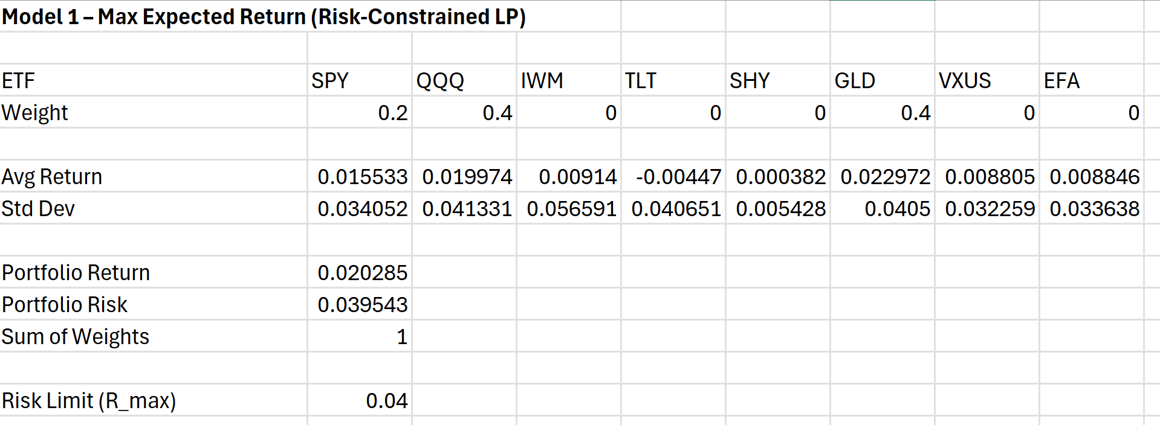
The model pushed heavily into the highest-return ETFs, resulting in a portfolio concentrated in SPY, QQQ, and GLD. It delivered the strongest return of all models (~2.03% per month) while staying just under the risk limit. This is the clearly aggressive option.

Model 2: Minimize Risk (Return-Constrained LP)
While Model 1 leans toward higher returns, this model is aimed at the opposite type of investor - someone who wants the lowest possible level of risk while still achieving a target return. This is often the mindset of conservative or near-retirement clients who would rather sacrifice some upside than experience large swings in their portfolio value.
The model operates by treating total risk as the objective function and constraining expected return instead. This flips the problem structure but accomplishes a similar balancing act. By forcing the portfolio to reach at least a minimum required return, the solution avoids simply placing all weight in the lowest-volatility ETF and instead spreads allocations across options that collectively meet the return goal with minimal risk.

Inputs:
i: index of the 8 ETFs in the portfolio
rᵢ: expected return of ETF i
σᵢ: volatility of ETF i (used as a linear risk approximation)
Rmin: the minimum required expected return for the portfolio
uᵢ: maximum allowable weight in ETF i

Decision Variable:
xᵢ: proportion of total investment allocated to ETF i

Objective:
Minimize total portfolio risk
Min ∑ σᵢ xᵢ

Constraints:
∑ rᵢ xᵢ ≥ Rmin
Ensures the portfolio meets the target return.
∑ xᵢ = 1
Fully invested portfolio.
0 ≤ xᵢ ≤ uᵢ
Diversification limits.
xᵢ ≥ 0
No short-selling.
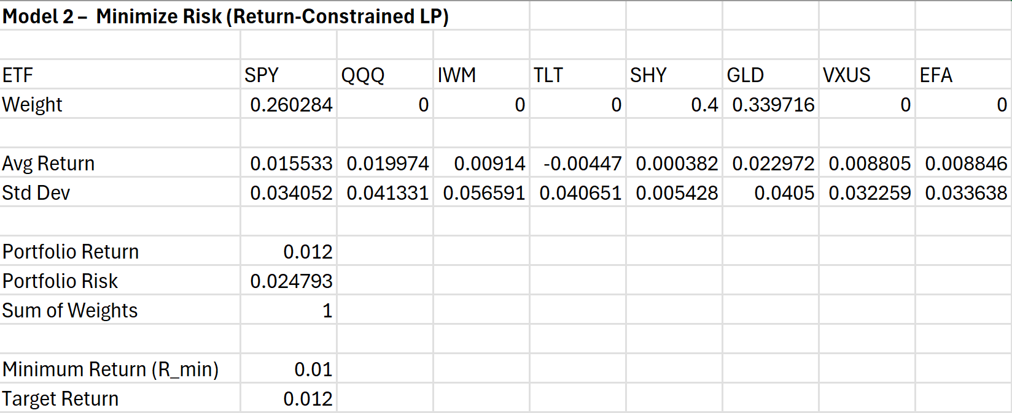
To meet the return requirement, the model leaned on low-volatility ETFs, mainly SHY, GLD, and SPY. Portfolio risk dropped to ~0.0248, one of the lowest, and the return came in right at the 1% target. This is a conservative, stability-focused allocation.

Model 3: Mean-Variance Tradeoff Model (Risk Aversion Parameter λ)
The third model combines risk and return directly in the objective function, creating a smoother tradeoff between the two. Instead of treating risk as a hard limit or a separate objective, return and risk are balanced using a risk-aversion parameter λ.
A higher λ penalizes risk more heavily, leading to a more conservative portfolio, while a lower λ allows for higher expected returns. This setup closely reflects how real investors balance risk and return in practice.
Inputs:
i: index of the 8 ETFs in the portfolio
rᵢ: expected return of ETF i
σᵢ: volatility of ETF i (used as a linear risk approximation)
uᵢ: maximum allowable weight in ETF i
λ: risk-aversion parameter selected by the advisor
Decision Variable:
xᵢ: proportion of total investment allocated to ETF i
Objective:
Maximize the tradeoff between return and risk
Max [ ∑ rᵢ xᵢ − λ * Risk(x) ]
Constraints:
∑ xᵢ = 1
0 ≤ xᵢ ≤ uᵢ
xᵢ ≥ 0
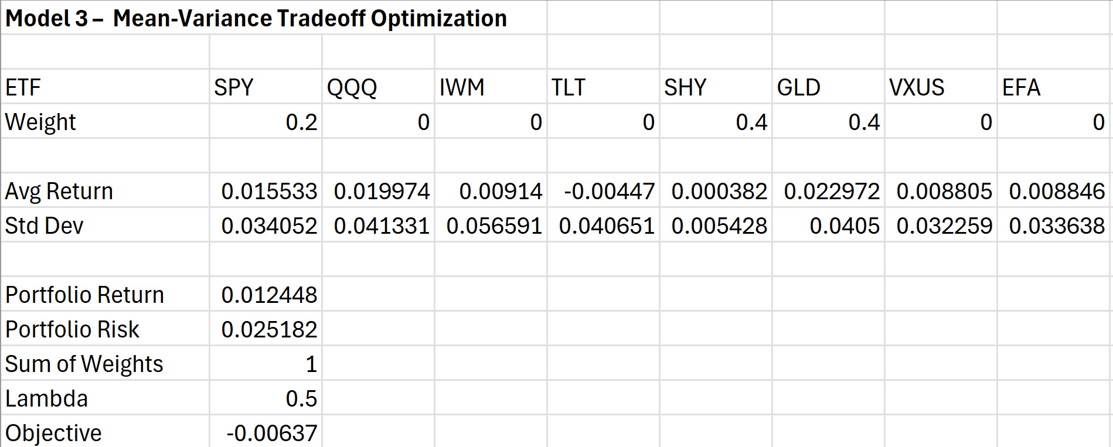
The solution balanced return and volatility by splitting across SPY, SHY, and GLD. It produced a moderate return (~1.24%) with moderate risk (~0.025), landing between the aggressive and conservative portfolios.

Model 4: Minimum Variance Portfolio (Quadratic Optimization)
The fourth model shifts from linear approximations to a more precise treatment of portfolio risk. Instead of using individual ETF volatilities, this model uses the full covariance matrix, which captures how ETF returns move together. This provides a more realistic estimate of total portfolio variance because diversification benefits arise when assets are not perfectly correlated.
The model’s goal is straightforward: find the allocation with the lowest possible portfolio variance. The model minimizes portfolio variance while still meeting a minimum return requirement. This is often used as a benchmark in practice because it generates the purest form of a “defensive” portfolio.
Since variance is quadratic in nature, the optimization becomes a quadratic programming problem rather than a linear one.
Inputs:
Σ: 8x8 covariance matrix of ETF returns
i: index of the 8 ETFs in the portfolio
uᵢ: maximum allowable weight in ETF i
Decision Variable:
xᵢ: proportion of total investment allocated to ETF i

Objective:
Minimize true portfolio variance
Min xᵀ Σ x

Constraints:
∑ xᵢ = 1
Ensures full investment.
0 ≤ xᵢ ≤ uᵢ
Diversification limits.
xᵢ ≥ 0
No short-selling allowed.
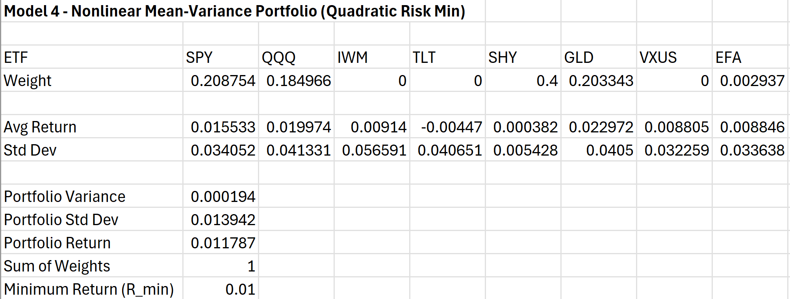
This portfolio produced the lowest volatility of the five models (~0.0139). SHY and GLD dominate the weights, with small allocations to SPY and QQQ. The return is modest (~1.18%) but the risk is the smallest by a wide margin.

Model 5: Scenario-Based Robust Portfolio (Maximin LP)
The fifth model takes a different perspective by evaluating the portfolio across all historical months individually. Rather than maximizing average returns or minimizing volatility, it focuses specifically on the worst monthly outcome. This leads to a portfolio that is designed to perform more consistently during stressful market periods.
In this model, each month of historical data is treated as a scenario. The decision variable z represents the return of the worst-performing scenario. By maximizing z, the model tries to “lift” the worst month as much as possible. This is the essence of a maximin approach: maximize the minimum result.
This robust structure is particularly attractive for risk-averse clients or anyone concerned with avoiding steep drawdowns. It does not guarantee high returns during good periods, but it helps protect the portfolio when markets struggle.

Inputs:
​​i: index for the 8 ETFs
k: index for each historical scenario (each month is one scenario)
sᵢₖ: return of ETF i in scenario k
K: total number of scenarios included in the model
uᵢ: maximum allowable weight in ETF i

Decision Variable:
xᵢ: weight of ETF i
z: the worst monthly portfolio return (a helper variable defined in Solver)

Objective:
Maximize the worst-case return
Max z

Constraints:
For every scenario k:
∑ sᵢₖ xᵢ ≥ z
Ensures the worst month is as high as possible.
∑ xᵢ = 1
The portfolio is fully invested.
0 ≤ xᵢ ≤ uᵢ
Diversification limits.
xᵢ ≥ 0
No short positions.
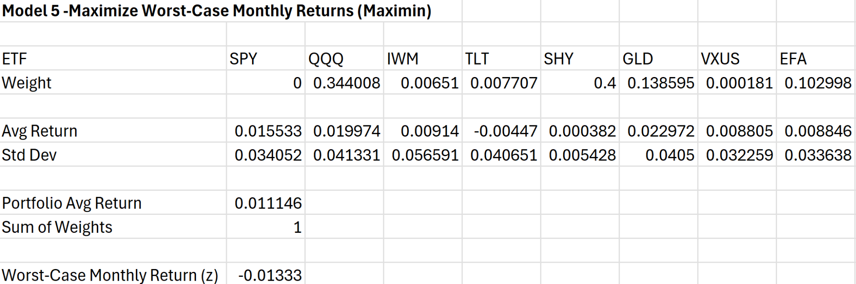
This model focused on reducing the damage in the worst historical month. It improved the worst monthly return to about -1.33%, which is noticeably better than leaving the weights unoptimized. The final allocation avoided ETFs that tended to drop sharply and shifted toward steadier funds like SHY, GLD, and a mix of international exposure. The average monthly return stayed reasonable (around 1.11%) while cutting some of the downside.

Model Comparison and Performance Analysis

After building the five models, we compared the resulting portfolios to better understand how different objectives affect performance and risk. Although each model uses the same underlying ETF data, the allocations vary significantly depending on whether the model prioritizes return, overall risk, or downside protection.
Models that focus on maximizing return tend to allocate more heavily toward higher-growth ETFs, which increases expected returns but also leads to greater volatility. On the other hand, models designed to minimize risk shift weight toward more stable assets such as short-term bonds and gold. This results in lower volatility, but also more limited upside potential.
Model 3 sits between these extremes by balancing return and risk, resulting in a portfolio with moderate volatility and steady performance. Model 4 further reduces overall volatility by accounting for correlations between ETFs, producing the lowest-risk portfolio of all five models. Model 5 differs from the others by focusing on worst-case performance rather than average outcomes, making it particularly useful for understanding downside risk during market stress.
These comparisons show that no single model dominates across all dimensions. Instead, each model highlights a different tradeoff between return, risk, and stability.

Recommended Portfolio Allocation

Rather than selecting a single optimization model, we recommend a blended portfolio that takes insights from Models 2, 3, and 4. These models consistently balance risk control with reasonable growth.

The recommended allocation is:

- 40% SHY
- 31% GLD
- 15% SPY
- 14% QQQ

This portfolio emphasizes stability through SHY and GLD, while SPY and QQQ provide measured exposure to equity growth. By blending multiple models, the allocation avoids extreme concentration and reflects a realistic option for a typical moderate-risk client.

Recommendations

In addition to individual model insights, the recommended blended portfolio provides a practical starting point for most moderate-risk clients.
- HWP should use different optimization models for different types of clients instead of relying on one standard allocation. Some clients may prefer higher expected returns, while others may value stability or downside protection.
- Scenario results from Model 5 can be useful during client conversations because they show how the portfolio would have performed during difficult months. This can help set realistic expectations about potential losses.
- The minimum variance and mean-variance models can be good options for clients who want a more stable return pattern without giving up too much performance.
- The models should be updated regularly as new ETF data becomes available. This keeps the allocations in line with current market conditions and ensures the process stays consistent over time.
- HWP may want to expand this framework later by adding more ETFs or additional constraints. This would allow the firm to customize portfolios even more as clients’ needs evolve.

Conclusion
The five optimization models highlight how different investment goals lead to different ETF allocations. Some portfolios aim for higher returns, while others are designed to reduce overall volatility or hold up better during difficult months. This makes it clear that there is not one portfolio that fits every client or every type of market. The right allocation depends on what the investor wants to prioritize.
Working with real ETF data helped us see how these objectives translate into practical portfolio weights. It also made the tradeoffs between return, risk, and downside protection easier to understand. The recommendations we developed follow directly from the model results and give HWP a straightforward way to match each client to the approach that fits their risk preferences.
Overall, this project showed that optimization can give HWP a more organized and consistent method for building portfolios. It reduces the amount of guesswork in the process and makes it easier to explain the reasoning behind each allocation. Using a structured model also makes it simpler to update portfolios as market conditions change. This approach can help HWP offer clearer guidance and better support for clients with a wide range of financial goals.

Citations
MarketWatch. (2024). Historical price data for SPY, QQQ, IWM, TLT, SHY, GLD, EFA, and VXUS. Retrieved from https://www.marketwatch.com
Horizon Wealth Partners Inc. (n.d.). Horizon Wealth Partners Inc. Retrieved December 10, 2025, from https://horizonwealthpartnersinc.com

